CSC 3020
Java Programming
Winter Term 2025
Project 02
35 points
Due 12/03/2025 (11:45 A.M.)

Library Management System

Objective:
Design and implement a JavaFX application that serves as a Library Management System. The system should allow users to manage books in a library, providing functionalities to add, remove, search, and list books.

User Interface:
Design a user-friendly GUI using JavaFX that allows users to perform actions with buttons, text fields, and other UI elements. Use layouts properly to ensure a clean and organized look for the application.
- Add Book: Users should be able to input the following details for each book:
  - ISBN (String)
  - Title (String)
  - Author (String)
- Remove Book: Users should be able to remove a book using its ISBN.
- Search by ISBN: Users should be able to search for a book by:
  - ISBN
- List All Books: Display a list of all books in the library with the following information:
  - ISBN
  - Title
  - Author
- Search by Author: Allow users to list all books by a specific author.
  - Author
- Display Image by ISBN: Users can display the cover image for a specific book by entering its ISBN. If the image exists in the specified directory, it will be shown on the interface.
- Save Books: Allow the user to save all books to books.txt file.
- Exit: Application exited successfully.

Data Management:
- The library_data.txt file for testing (initially with a few sample records).
- Each book in the library_data.txt file has an image file in the image folder
- File Handling: Implement functionality to read and write book data from/to a text file (library_data.txt):
  - When the application starts, load existing book data from the file.
  - Upon exiting, save the current book data to the file.
- Use a suitable format for the file (e.g., each book record on a new line, separated by a delimiter).

Documentation:
- Comment your code adequately to explain the functionality of various classes and methods.

Deliverables
- A complete JavaFX application with the source code. Convert the source code of each file (3 files) to a txt file.
- Create a user manual (1 page) detailing how to use the application, its features, and how to compile/run it. Brief instructions on how to run the application.

Submission Deadline
- Your application should be submitted by the date listed at the beginning of the assignment.
- Plan your project before coding.
- Break down tasks into smaller parts and tackle them one by one, such as starting with the book class, UI layout, and then file handling.
- Ensure to test your application thoroughly to catch and fix any bugs before submission.

Restrictions:
You must work individually. Use only material from class or from the textbook (chapters 1- 17). All code must be the work of the individual. Do not share your code or copy from external resources.

Below are examples of a sample input file for your Library Management System and a detailed walkthrough of sample outputs for each of the functionalities mentioned.

Sample Input File: library_data
You can create a text file named library_data.txt with the following content. Each record is separated by a new line, and fields are delimited by a comma (,).
978-3-16-148410-0,The Great Gatsby,F. Scott Fitzgerald
978-1-86197-876-9,To Kill a Mockingbird,Harper Lee
978-0-7432-7356-5,The Catcher in the Rye,J.D. Salinger
978-0-452-28423-4,1984,George Orwell
978-0-7432-7357-2,Pride and Prejudice,Jane Austen
978-0-06-112008-4,The Alchemist,Paulo Coelho
978-0-394-82345-8,Dune,Frank Herbert
978-0-7432-7358-9,Moby Dick,Herman Melville
978-0-316-76948-1,Brave New World,Aldous Huxley
978-0-345-39180-3,Fahrenheit 451,Ray Bradbury
978-6-557-82063-6,Animal Farm,George Orwell

You may use the text file provided with the assignment, which contains the same records. In addition to the text file, you may also use the image folder. The folder contains an image file for each of the books listed above.

Sample Outputs for Each Functionality
Here’s a detailed walkthrough of the sample outputs you might see while testing each of the functionalities of your library application.
- List All Books
User Action: Click the "List All Books" button.
Sample output in text area:
List of all books:
ISBN: 978-3-16-148410-0, Title: The Great Gatsby, Author: F. Scott Fitzgerald
ISBN: 978-1-86197-876-9, Title: To Kill a Mockingbird, Author: Harper Lee
ISBN: 978-0-7432-7356-5, Title: The Catcher in the Rye, Author: J.D. Salinger
ISBN: 978-0-452-28423-4, Title: 1984, Author: George Orwell
ISBN: 978-0-7432-7357-2, Title: Pride and Prejudice, Author: Jane Austen
ISBN: 978-0-06-112008-4, Title: The Alchemist, Author: Paulo Coelho
ISBN: 978-0-394-82345-8, Title: Dune, Author: Frank Herbert
ISBN: 978-0-7432-7358-9, Title: Moby Dick, Author: Herman Melville
ISBN: 978-0-316-76948-1, Title: Brave New World, Author: Aldous Huxley
ISBN: 978-0-345-39180-3, Title: Fahrenheit 451, Author: Ray Bradbury
ISBN: 978-6-557-82063-6, Title: Animal Farm, Author: George Orwell
- Add a Book
User Action: Enter data for a new book (e.g., ISBN: 978-1-4088-5565-2, Title: The Fault in Our Stars, Author: John Green), and click the "Add Book" button.
Sample output in text area:
Book added successfully!
ISBN: 978-1-4088-5565-2, Title: The Fault in Our Stars, Author: John Green
- Remove a Book
User Action 1: Enter ISBN 978-3-16-148410-0 (valid) and click the "Remove Book" button.
Sample output in text area:
Book removed successfully!
User Action 2: Enter ISBN 123-4-56-78901-2 (invalid) and click the "Remove Book" button.
Sample output in text area
Book not found. Please check the ISBN.
- Search for a Book by ISBN
User Action 1: Enter ISBN 978-1-86197-876-9 (valid) and click the "Search" button.
Sample output in text area:
Book found: ISBN: 978-1-86197-876-9, Title: To Kill a Mockingbird, Author: Harper Lee
User Action 2: Enter ISBN 123-4-56-78901-2 (invalid) and click the "Search" button.
Sample output in text area:
Book not found.
- Search by Author
User Action 1: Enter Author George Orwell and click the "Search by Author" button.
Sample output in text area:
Books by George Orwell:
ISBN: 978-0-452-28423-4, Title: 1984, Author: George Orwell
ISBN: 978-6-557-82063-6, Title: Animal Farm, Author: George Orwell
User Action 2: Enter Author Nonexistent Author (not in the list) and click the "Search by Author" button.
Sample output in text area:
No books found by this author.
- Image by ISBN
User Action: Enter a valid ISBN (e.g., 978-6-557-82063-6) and click the "Display Image by ISBN" button.
Sample output in text area:
Displaying image for ISBN: 978-6-557-82063-6

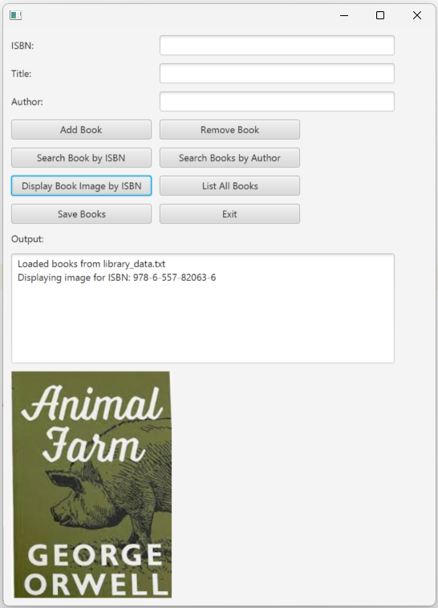

- Save Books
User Action: After making changes (adding/removing books), click the "Save Books" button.
Sample Output:
Books saved to books.txt successfully!
- Exit Application
User Action: Click the "Exit" button.
Sample Output:
Application exited successfully.

Grading Rubrics

Criteria | Points | Description
Core Functionalities | 15 | Add Book (5 pts): Users can input ISBN, Title, and Author to add a new book. Book is added to the collection (Library class). UI updates accordingly.  Remove Book (4 pts): Users can remove a book by entering ISBN. Book is successfully removed from the collection. Appropriate feedback is given in the output area.  Search by ISBN (2 pts): Correctly searches for a book using ISBN. Displays the book details if found; shows error message if not.  List All Books (2 pts): Displays all books in the collection with ISBN, Title, and Author. Output appears in the TextArea when button clicked.  Display Book Image (2 pts): Shows the cover image based on ISBN from the images/ folder. Handles missing images gracefully.
Class Design & Data Handling | 6 | Book class: Encapsulates ISBN, Title, Author.  Library class: Manages collection with methods: addBook(), removeBook(), searchByISBN(), searchByTitle(), listAllBooks(), loadBooksFromFile(), saveBooksToFile()
User Interface & Layout | 5 | UI Components: Proper use of GridPane, BorderPane, buttons, text fields, labels, image view, and output area.  Layout: Organized, intuitive, and user-friendly interface.  Controls: Buttons are properly sized and positioned.  Correct Behavior: Each button performs its intended function reliably.  Feedback: Outputs success or error messages accordingly.
File Handling & Data Persistence | 6 | Loading Data: Loads existing books from library_data.txt at startup.  Saving Data: Saves current collection on save or exit.  File Format: Uses CSV format with ISBN, Title, Author.  Display Image: Correctly shows image from images/ folder based on ISBN when button clicked.  Input Validation: Checks for empty or invalid inputs.  Graceful Handling: Handles file errors, missing images, and invalid searches with user feedback.
Code Quality & Structure | 3 | Organization: Clear separation of classes (Book, Library, main application).  Readability: Proper indentation, naming conventions, and comments.

